TABLE OF CONTENTS

1 INTRODUCTION 2

2 INFORMATION SYSTEMS COMPONENTS 3

2.1 HARDWARE 3

2.2 PEOPLE 4

2.3 NETWORK 4

2.4 DATA RESOURCES 5

2.5 SOFTWARE 5

3 INFORMATION SYSTEMS IN ORGANIZATIONS 6

3.1 TRANSACTION PROCESSING SYSTEMS (TPS) 8

3.2 MANAGEMENT INFORMATION SYSTEMS (MIS) 9

3.3 EXECUTIVE INFORMATION SYSTEMS (EIS) 9

4 CONCLUSION 11

REFERENCES 12

# 1 INTRODUCTION

When talking about Information Systems (IS) and Information Technology (IT) in Organizations, we shall start with some definitions. According to the Cambridge Dictionary, IT is “The science and activity of using computers and other electronic equipment to store and send information”. Again according to Cambridge Dictionary, Organization means “a group of people who work together in an organized way for a shared purpose”.

Information Systems are a combination of people, hardware, software, networks, data resources, and policies and procedures in an organized way to store, retrieve, transform and distribute information within an organization (Maracas & O’Brien, 2013). This theme will be explored along this research.

Contextualizing, we are living in a world where two billion people tap into internet, around five billion people use sophisticated mobile phones and there is cell service everywhere, which means that it’s becoming completely difficult to go anywhere without being caught in a digital technology (Greengard, 2011). It is no different within organizations. Businesses need to be creative at all times otherwise it will rapid become obsolete. This is the moment when IT comes to help develop all different king of business. IS nowadays are pervasive. Delivery companies uses IS to rout trucks and track packages; retailers for optimizing supply chains, to record purchases and analyzing customer tastes and preferences, among others; pay checks are probably generated by computer (Valacich & Schneider, 2016).

Valacich and Schneider (2016) also said that companies are being forced by the worldwide competitiveness to find ways to do things better and less expensive and the reasons why these firms continues to be is by using IS to deliver their products - whichever they are - better, faster, and cheaper.

Since 1955 we have witnessed how industrial organizations are being attacked (in a positive way) by the computers and computer-related activities - management information systems (Gorry & Scott Morton, 1971).

In this research we will see the different Information Systems existing and how they interact to provide a good running in organization.

# 2 INFORMATION SYSTEMS COMPONENTS

Briefly, is important to recognize each component of IS which are people, hardware, software, networks, stored data; and how they interact among them to provide good results within the company.

## 2.1 HARDWARE

According to Malaga (2005), is the physical parts of the IS, it is basically the parts of the computer which you can touch, including input and output devices.

Figure 1: Typical Computer Hardware

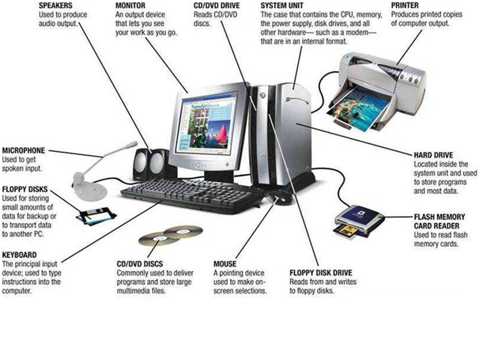

Source: Seal, S., (2016)

There are several types of computers; such as supercomputers, mainframes, desktops, workstations, laptops, its use depends on what do you need it for.

Also input devices which can differ on what kind of information you want to introduce to your computer, for example, if you want to type a text you can use the keyboard to input the text you desire, or you can use a mouse to click on the information you want to process.

Output devices are how the information is presented after being processed by the computer. The most common output device is the monitor, but there are also speakers.

## 2.2 PEOPLE

Maracas and O’Brien (2013) says that people “rely on modern information systems to communicate with one another using a variety of physical devices” such as hardware, software, data resources. We can say that people is who use the IS in its many way to get different results – by inputting information or receiving information for example.

## 2.3 NETWORK

Figure 2: Network connections

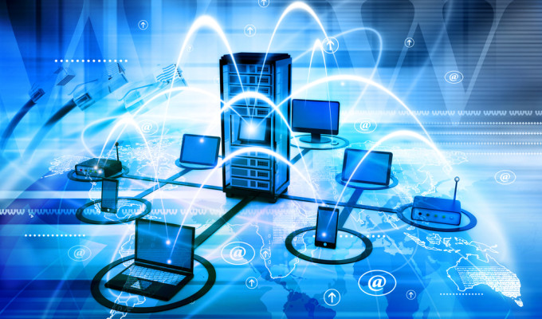

Source: Mimoso, M., (2015)

The Network role on Information System is to allow the different computers within a company to communicate with each other. They are very important for the distribution of the information (Malaga, 2005).

“Taken alone, each individual piece of technology has little value; it is through connecting the different pieces that business value can be realized” (Valacich & Schneider, 2016). This means that information needs to be accessed by those people or application in the organization that depend on the data. Still according to Valacich and Schneider (2016), networking and its ability to interconnect is the reason why IS are so powerful and important.

## 2.4 DATA RESOURCES

Data are raw facts (Malaga, 2005). They are stored and retrieved in organizations to be transformed in information and it can be used to determine for example “Who is the best customer?”, “Which product was bought?”, “When the customer bought the product?” – Important on cases of exchange or refund, “Which salesperson served the customer?” among other use.

## 2.5 SOFTWARE

Software is information processing instruction and procedures (Maracas & O’Brien, 2013). This means they are the programs that act within the computer to process the instructions given by the user (manager, salesperson, executive).

We can see now on the Figure 3 below the interaction between the different components of an Information System.

Figure 3: Information Systems components.

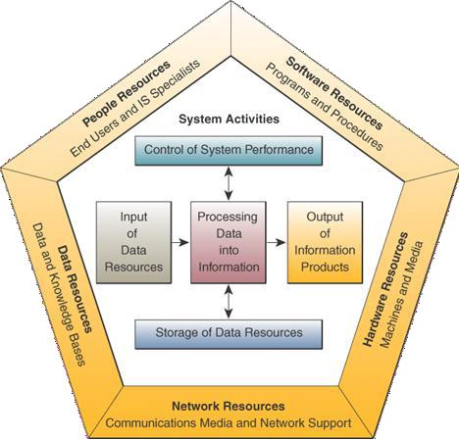

Source: (Maracas & O’Brien, 2013)

# 3 INFORMATION SYSTEMS IN ORGANIZATIONS

In the beginning of computing, every time a company needed a IS, it was built specifically for its purpose as an on-off solution for a particular problem. However, these problems became familiar to other IS built with the same characteristics. Consequently people came with the idea of building on a single IS to solve all similar problems. With this concept they realized it was important firstly to define how and where the IS would be used and why it was needed (Kimble, C., 2010).

Through a process of classification, a different number of types of IS can be found. When applying an IS classification, it is necessary to take into consideration the different problems and tasks found within the organization.

Three different classifications will be mentioned here, they are all interrelated in some way, but only one will be used to know the Information systems connected to it, the data and information needed at each level.

Some authors use a five level pyramid model (Figure 4) which is based on the different types of data, information and knowledge that are processed at different levels in the company.

Figure 4: Five level pyramid model.

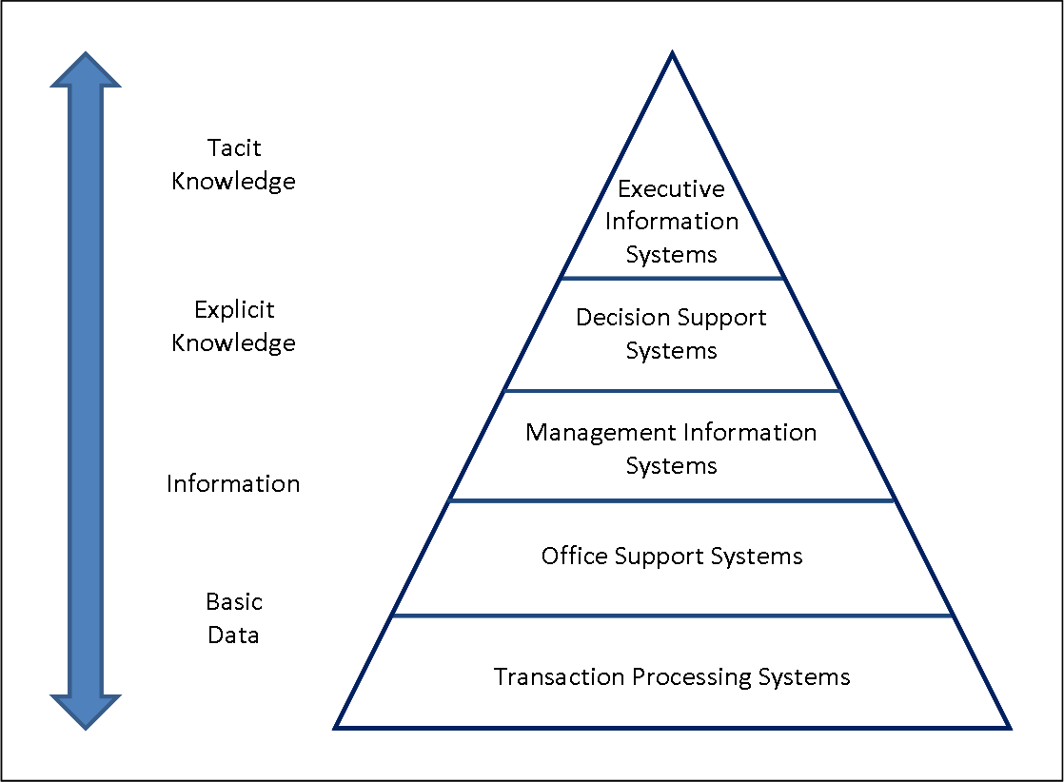

Source: Kimble, C., (2010).

Secondly, a four level pyramid (Figure 5) version based on the people who use the systems.

Figure 5: Four level pyramid.

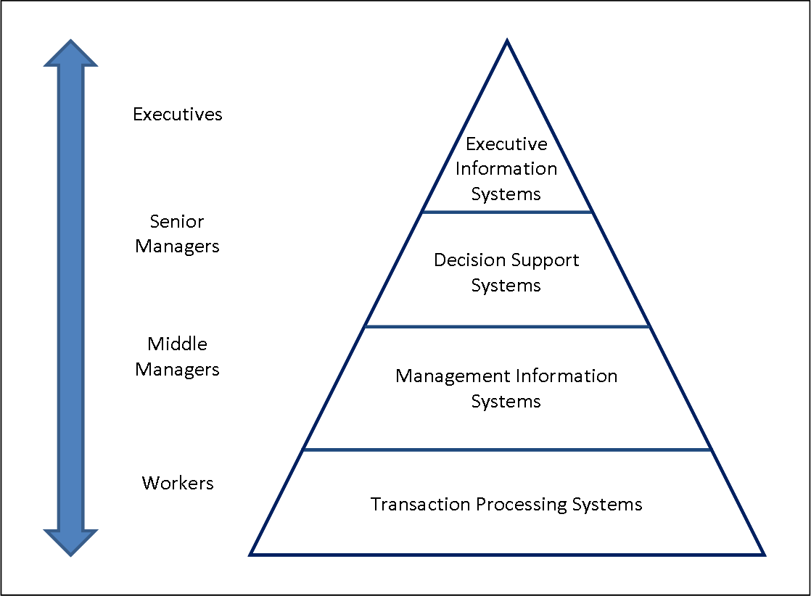

Source: Kimble, C., (2010).

The last classification that will be mentioned here and analysed afterward is the three level pyramid (Figure 6) developed by Robert Antony in his book “Planning and Control Systems: A Framework for Analysis, 1965” which is based on the type of decisions taken at different level within the organization. Robert Antony’s classification has been improved with modern times and the emerging of new technologies, but its essence is still the same.

Figure 6: Three level pyramid

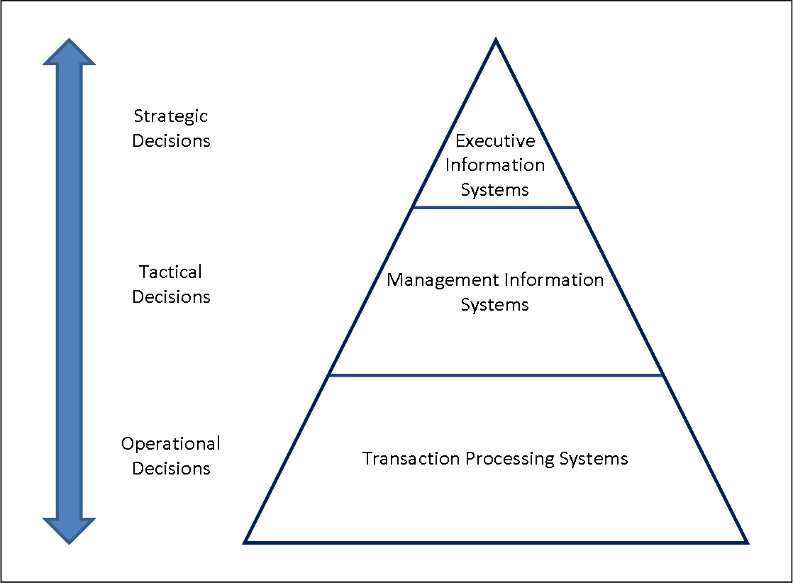

Source: Kimble, C., (2010).

## 3.1 TRANSACTION PROCESSING SYSTEMS (TPS)

Starting from the bottom of the pyramid we can find the Transaction Processing System (TPS) which has operational decisions connected to it. According to Takahara (2005) TPS is “an information system designed to process day-to-day business event data at the operational level of an organization”. Operational decisions are likely to affect short term management to run daily business process activities to reach short term goals (Abahmane & Binkkour, 2015). Operational System “is designed to improve efficiency and effectiveness by automating back office data processing functions and improving information flows and transfers” (Elizabeth & Galliers, 1987).

Still according to Abahmane and Binkkour (2015) the frequency of production on the operational level is routinely on a regular basis to show the continuous activity of the organization, they are relevant only to the short and medium term. They use quantitative information to make these decisions and they are less influenced by the external environment and data because it is primarily generated internally.

They are usually operated by shop floor workers or front line staffs, who provide the data to support management Information Systems. Some examples of TPS can be Payroll Systems, Order Processing Systems, Reservation Systems, Stock Control Systems, Systems for payments and funds transfers.

This system can also encompass Office Automation Systems (OAS) which is used by secretaries and bookkeepers to create, to use and manipulate data but they do not generate new information. And Knowledge Work Systems (KWS) which provides information to be used by Lower level employees. They are highly specialized systems and it is used by knowledge workers (Malaga, 2005).

## 3.2 MANAGEMENT INFORMATION SYSTEMS (MIS)

According to Marakas and O’Brien (2013), this system is focused on developing business applications with predefined management report that would give managers the necessary information for decision-making (tactical) purposes. This system is built on internal data provided by the TPS; it helps ensure the normal running of the company in the short and medium term performing routine tasks. Some examples of MIS are Sales management systems, Inventory control systems, Budgeting systems, Management reporting systems.

By the 1970s the product of MIS were not meeting the decision-making need of the management, so it was created the Decision Support Systems (DSS) (Marakas & O’Brien, 2013). These systems use complex analytical tools, combined with internal – provided by the TPS - and external data like economic indicators, competitors’ products, or industry moves (Malaga, 2005).

## 3.3 EXECUTIVE INFORMATION SYSTEMS (EIS)

Marakas and O’Brien (2013) said that EIS were created with the purpose to give top executive an easy way to get the critical information they wanted, whenever they wanted and put on the format they preferred.

The strategic data is produced on demand, on an ‘ad hoc’ basis as requested by high management; it is relevant to long term strategic decisions which are based on quantitative and qualitative information. The data is provided by both internal and external data and is not frequently used (Abahmane & Binkkour, 2015).

There is also an Interorganizational System, which is a system that provide information links between companies, it can exist in different levels of the hierarchy which means that it can become an extension of knowledge work systems and maybe decision support systems.

# 4 CONCLUSION

We can see now how important Information Systems are within organizations, each level, each employee and all types of decisions can be simplified with the use of IS. The most important thing when opening a company or to maintain it is to consider the right questions you should make to make it a long term business.

The digital world changes on a daily basis, different ideas, different procedures or ideas more sophisticated than the previous merge every day. With that in mind new business and the existing ones should invest on new technologies, but it could never complicate the use of it on simple tasks.

To choose which pyramid will be used as a base to a company’s purpose is very important, but on the other hand they all have the same characteristics, they differ on which component is more important for the organization – whether the people who will use it or the decision you want from it or which kind of information you want for it.

# REFERENCES

Marakas, G.M. and O'Brien, J.A., (2013). *Introduction to information systems*. 16th edn. McGraw-Hill, Inc., New York.

Greengard, S. (2011). Living in a Digital World. *Communications Of The ACM,* ***54***(10), 17-19.

Valacich, J., & Schneider, C. (2016). *Information systems today managing in the digital world* 17TH edn, Boston: Pearson.

Boriev Z., Nyrkov A., Sokolov S., & Chernyi S. (2016). Software and hardware user authentication methods in the information and control systems based on biometrics. Paper presented to the Conference Series: Materials Science and Engineering*,* ***124***(1), 6.

Gorry, G.A. and Scott Morton, M.S., (1971). A framework for management information systems, Working paper Alfred P. Sloan School of Management, Massachusetts.

Robert Anthony, Planning and Control Systems: A Framework for Analysis, Graduate School of Business Administration, Harvard University Boston, (1965). Cited in Gorry, G.A. and Scott Morton, M.S., (1971). A framework for management information systems, Working paper Alfred P. Sloan School of Management, Massachusetts.

Takahara, Y., Liu, Y., Chen, X., & Yano, Y. (2005). Model theory approach to transaction processing system development. *International Journal of General Systems,* ***34***(5), 537-557.

Abahmane, O., & Binkkour, M. (2015). *Strategic and Operational information support of decision making processes and systems*. Proceedings of the Information Systems and Business Intelligence Conference, Feb 2008, Hammamet, Tunisia.

Elizabeth K. S., Robert D. G., (1987), “Towards Strategic Information Systems” Vol 1, 1st Edition, Abacus Press. In Abahmane, O., & Binkkour, M. (2015). *Strategic and Operational information support of decision making processes and systems*. Proceedings of the Information Systems and Business Intelligence Conference, Feb 2008, Hammamet, Tunisia.

Malaga, R. A. (2005). *Information systems technology*. Upper Saddle River, NJ: Pearson Prentice Hall.

Kimble, C., (2010), *Different Types of Information System and the Pyramid Model*. [Online], Available: http://www.chris-kimble.com/Courses/World_Med_MBA/Types-of-Information-System.html. [2017, Nov. 7].

Mimoso, M., (2015), *Critical Flaws Found in Network Management Systems.* [Online], Available: https://threatpost.com/critical-flaws-found-in-network-management-systems/115649/. [2017, Nov. 9].

Seal, S., (2016), *Computer Hardware*. [Online], Available: http://www.bngkolkata.com/web/computer-hardware/. [2017, Nov. 9].